EXPERIMENT 7
EDA – CORRELATION ANALYSIS
Aim
To analyze the relationship between numerical variables in the Customer Churn dataset using correlation analysis and a heatmap.
Procedure
1. Load the Customer Churn dataset using Pandas.
2. Select the numerical columns from the dataset.
3. Calculate the correlation matrix.
4. Display the correlation values.
5. Create a heatmap to visualize the correlation matrix.
6. Analyze the strength and direction of relationships between numerical variables.
Python Code
import pandas as pd
import matplotlib.pyplot as plt
import seaborn as sns

# 1. Load dataset
df = pd.read_csv("WA_Fn-UseC_-Telco-Customer-Churn.csv")

# 2. Select numerical columns
numeric_data = df.select_dtypes(include="number")

# 3. Calculate correlation
correlation = numeric_data.corr()

print("Correlation Matrix:")
print(correlation)

# 4. Create heatmap
plt.figure(figsize=(8, 6))

sns.heatmap(
correlation,
annot=True,
cmap="coolwarm",
fmt=".2f"
)

plt.title("Correlation Heatmap")
plt.show()
Code Output
Correlation Matrix:
SeniorCitizen tenure MonthlyCharges
SeniorCitizen 1.000000 0.016567 0.220173
tenure 0.016567 1.000000 0.247900
MonthlyCharges 0.220173 0.247900 1.000000
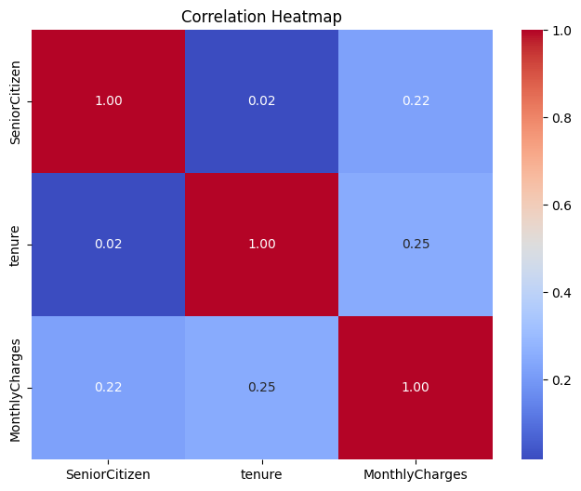

Result
The correlation between numerical variables in the Customer Churn dataset was successfully calculated and visualized using a heatmap. The analysis helped identify the strength and direction of relationships between numerical features.

